NAME: DATE:
WEBSITE VOCABULARY

- At the end of a website is the:

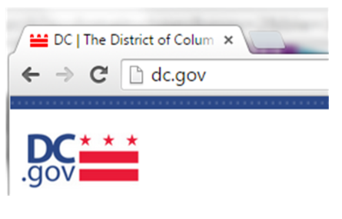

- What is the website?

What is at the end?

- What is the website?

What is at the end?

- What is the website?

What is at the end?

- What is the website?

What is at the end?

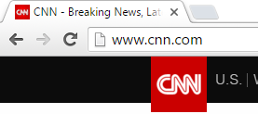
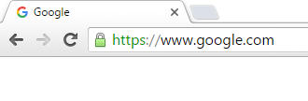
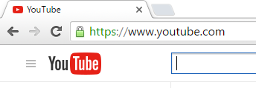
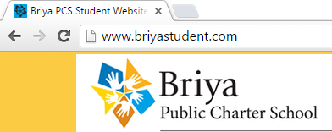

- What is the website?

What is at the end?

- What is the website?

What is at the end?

- What is the website?

What is at the end?

- What is the website?

What is at the end?

10. What is the website?

What is at the end?

11. What is the website?

What is at the end?

