Name:
Date:
- Read and match. Change highlight color to yellow.

up – right – go upstairs – left – go downstairs – down

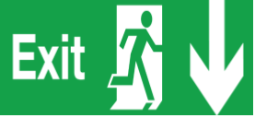
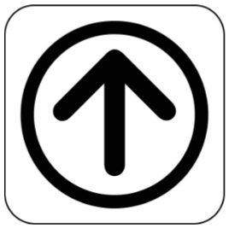

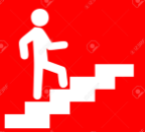

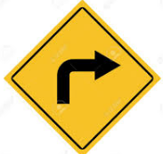

- Highlight color the directions in red.

The yellow car turns left. The clinic is on the right.
The office upstairs. Go up and turn to your right. The restrooms are downstairs. Go down and turn to your left.

