Name:
Date:
- Read and match. Change font color to purple.

up – right – go upstairs – left – go downstairs – down

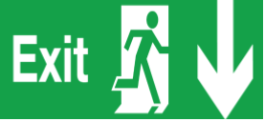
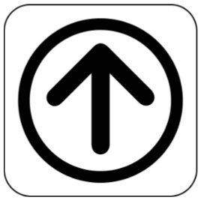

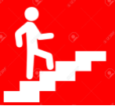

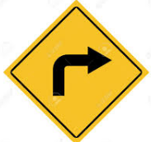

- Color the directions in blue.

The yellow car turns left. The clinic is on the right.

The office upstairs. Go up and turn to your right. The restrooms are downstairs. Go down and turn to your left.

